National Aviation University
Aerospace Faculty

Laboratory Work #2
« Basic mathematical problems with MATLAB,
first (simple) algorithms»

Completed: first year student
of ASF 117
Zakorko Denis
Take: Gaev Evgen
Oleksandrovich

Kiev 2019


Laboratory Work #2
Basic mathematical problems with MATLAB,
first (simple) algorithms.

Goal: convince you to use MATLAB for solution key problems of your mathematics course, particularly (1) of linear algebra and systems of linear algebraic equations (SLAE), (2) solution transcendental equations of one unknown. Note particularly the fundamental difference between analytical and numerical calculations in the MATLAB. Prepare for starting programming by manual realization of some simplest (but nice-:) algorithms.
A secondary goal of this Laboratory Work is to encourage students for applying MATLAB in other university disciplines, in mathematics first of all.

- Gauss Method, Cramer’s Rule. Commands linsolve, solve

- Determinant of a matrix A could be found by det(A), then inverse matrix could be calculated by inv(A) if it is possible: det(A)!=0

- Cramer’s method:
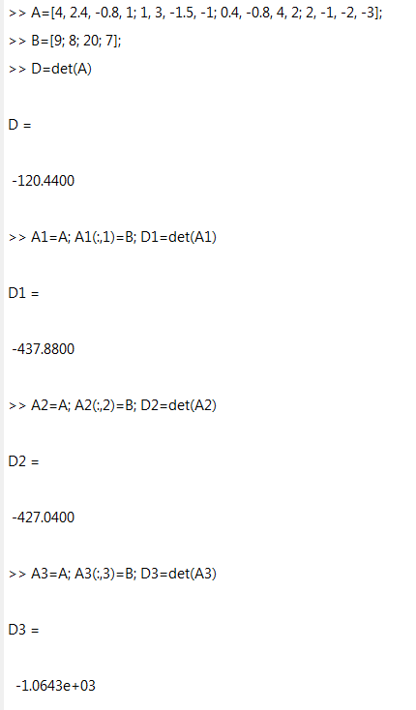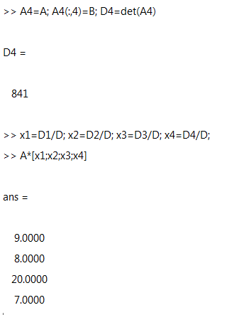
Inverse matrix method:

4. 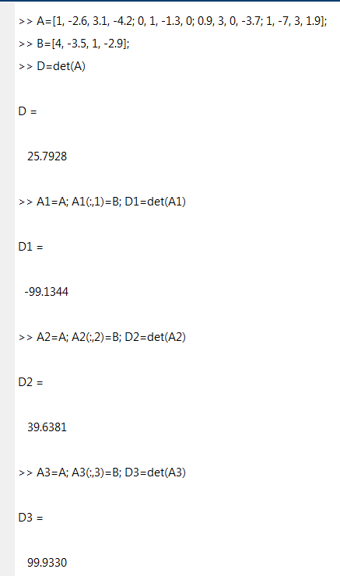

5.Any values of a gives us solve(cos(x)==ax) = 0
But if we use fzero, we get
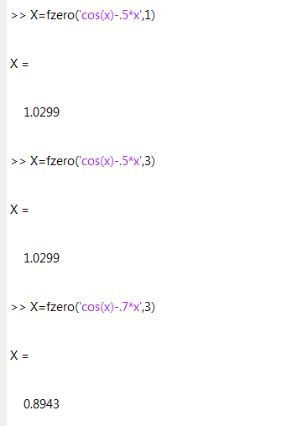
So I used graph method.

I built a graph of cos=x
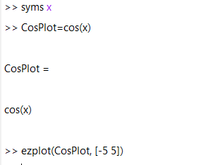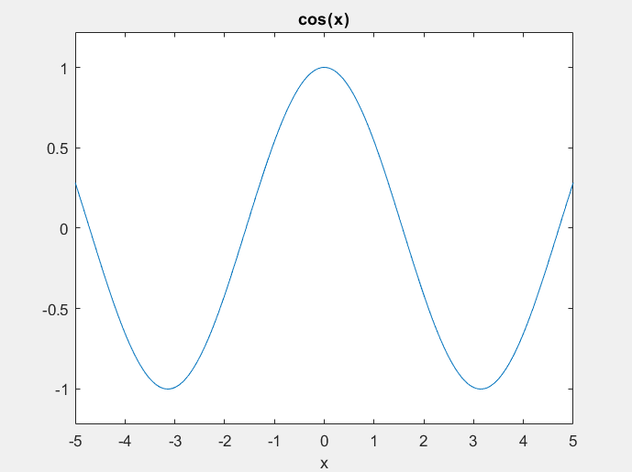

Then a=2
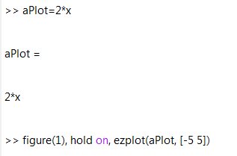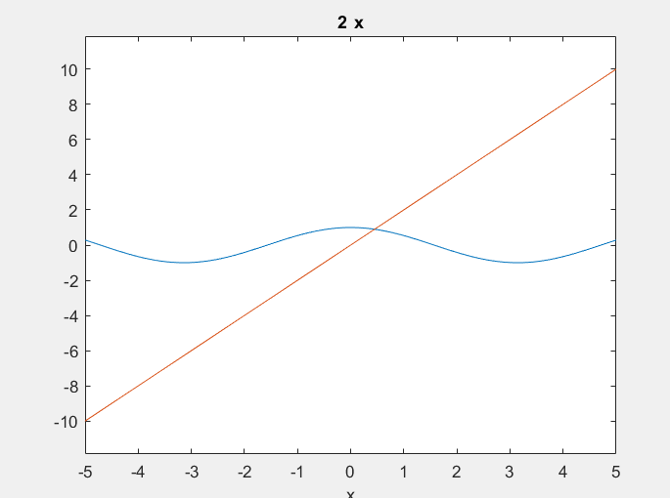

Then a=-3

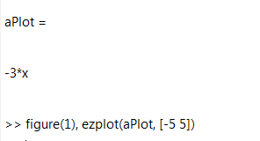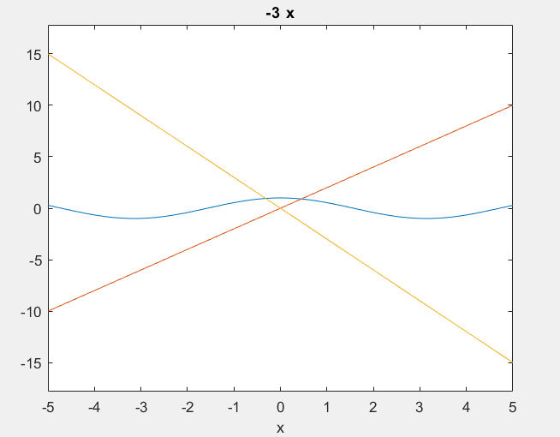
If a =2 and -3, cos(x)=ax have only two roots.

6. Solve Method
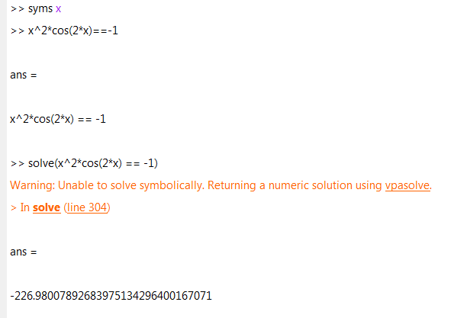

Graph method
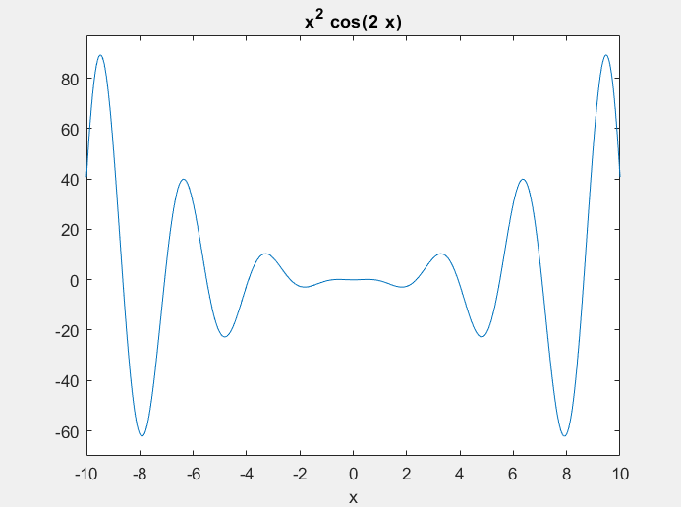

7. 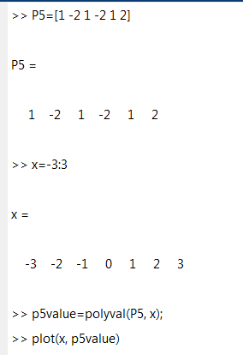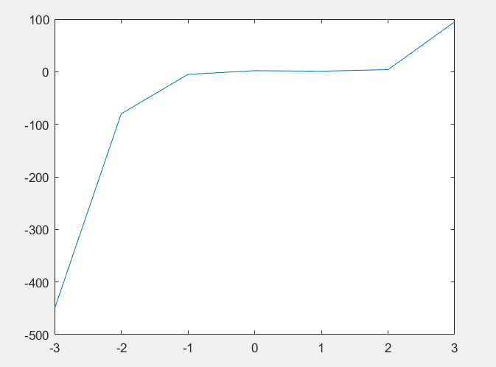

- 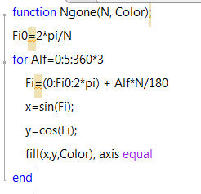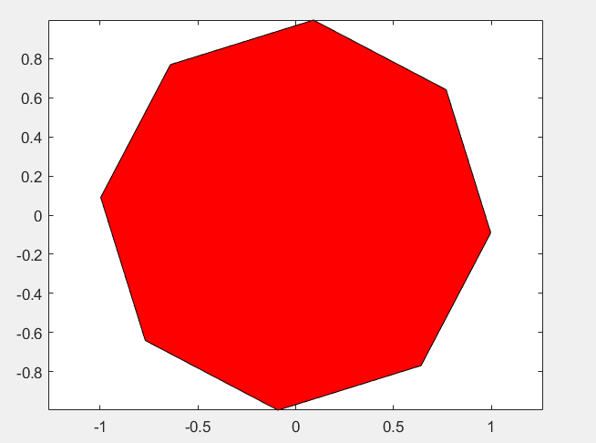

I can create m-function Ngone with variable N, for example 8. And for example fill Ngone with red color.
- 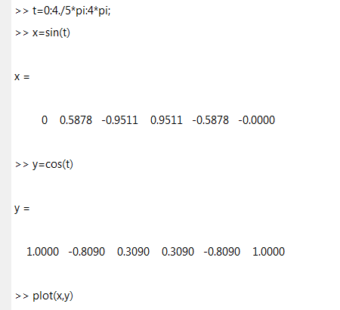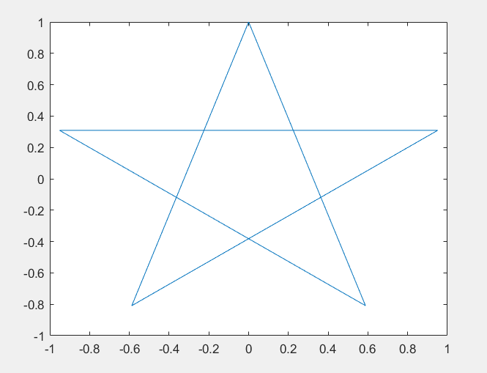
11.1. 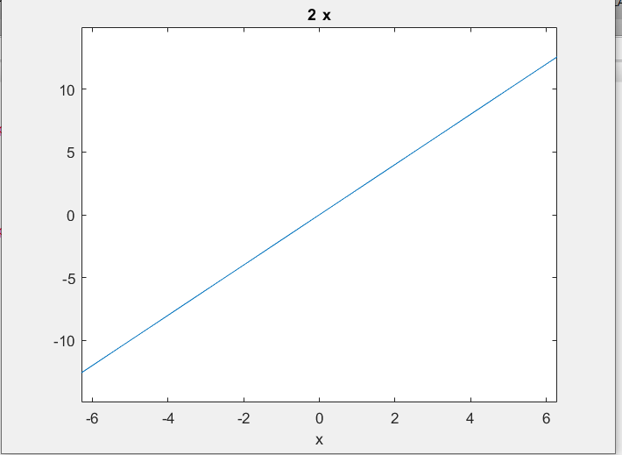
15. Numeric objects are allow to work with numbers and do all algebraic operations. Symbolic data type is such text expression that could be interpreted as correct mathematical expression. Because the variable is a symbol, you can assign different values to it at different times. By assigning different values, you can do the same processing with different data.

16. Yes, I like MatLab, it is very useful for me. Especially it is easier to determine matrixes and doing algebraic operations with them.
Attachment 1
Solve the following SLAE:
1.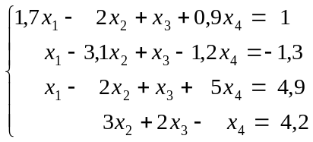 2.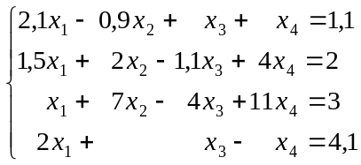
3.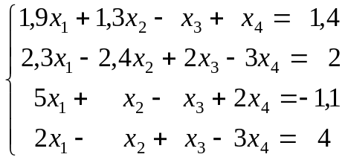 4.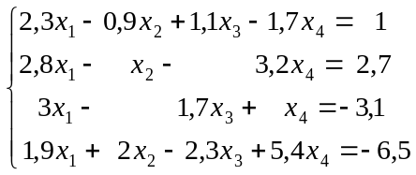
5.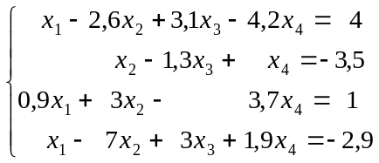 6.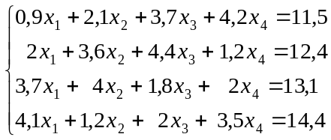
7.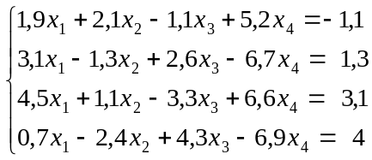 8.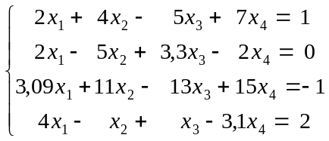
9.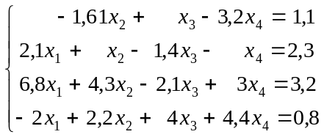 10.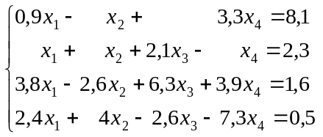
11.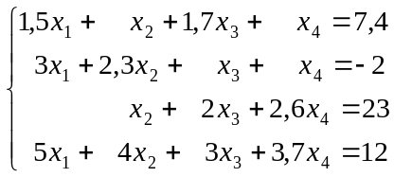 12.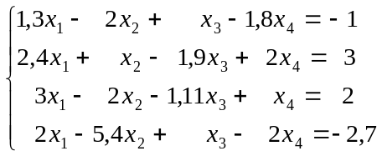

Attachment 2
Solve the following transcendental equations. Analyze particularly how much solutions does it have.

№ 1. 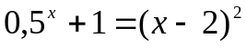 № 2. 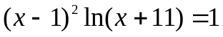

№ 3. 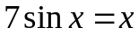 № 4. 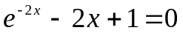

№ 5. 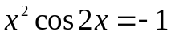 № 6. 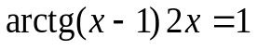

№ 7. 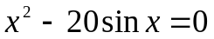 № 8. 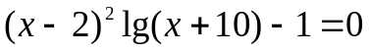

№ 9. 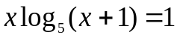 № 10. 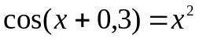

№ 11. 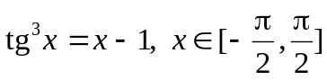 № 12. 